Forescout Continuous Monitoring NAC: Executive Summary
Overview
This document presents a strategic architecture for implementing continuous, posture-based Network Access Control (NAC) using Forescout as the central RADIUS enforcement platform. The solution delivers real-time security posture validation and dynamic access control across corporate, retail, and distribution environments without requiring changes to existing VLAN structures or network topology.
Business Challenge
Traditional MAC-based authentication grants persistent network access based solely on device identity, creating significant security gaps. Once authenticated, devices maintain full network privileges regardless of security posture degradation—missing patches, disabled agents, emerging threats, or active compromise. This static model enables lateral movement, data exfiltration, and prolonged attacker dwell time.
Organizations require a solution that continuously validates device trustworthiness and dynamically adjusts network privileges in real time, while preserving existing infrastructure investments and operational workflows.
Solution Architecture
Core Capabilities
The Forescout NAC architecture delivers continuous security enforcement through four integrated capabilities:
Dynamic Device Classification — Automatic identification of device types (managed endpoints, unknown Windows/macOS, IT IoT, OT IoT) using DHCP fingerprinting, MDM enrollment status, and agent presence detection
Multi-Source Posture Aggregation — Real-time security health evaluation combining telemetry from Forescout, CrowdStrike Falcon, Qualys Cloud Agent, Tanium, and Zscaler ZIA
Automated Access Control — RADIUS-based enforcement applying dynamic ACLs on switches and wireless controllers via Change of Authorization (CoA) without disconnecting devices
Self-Healing Remediation — Automatic access restoration when devices resolve posture issues, eliminating helpdesk intervention
Enforcement Model
The architecture implements risk-proportional enforcement based on device classification and continuous posture evaluation:
Device Class | Posture Criteria | Enforcement Approach
Managed Windows/macOS Endpoints | Three-tier continuous evaluation: Tier 1 (full compliance), Tier 2 (partial compliance), Tier 3 (compromised/critical risk) | Strict posture-based access control; non-compliance triggers immediate restriction or block
Unknown Windows/macOS | Not enrolled in MDM; missing required agents | Deny by default or captive portal enrollment until authorized
IT IoT Devices | Printers, cameras, VoIP phones, badge readers, network equipment | Discovery-first approach with progressive functional ACL governance
OT IoT Devices | Industrial controllers, medical devices, building management, SCADA systems | Baseline profiling with availability-prioritized micro-segmentation

Table 1: Device classification and enforcement model
Three-Tier Posture Framework
Managed Windows and macOS endpoints are dynamically assigned to posture tiers based on continuous security validation:
Tier 1 — Full Access: All security agents healthy and current (Forescout, CrowdStrike, Qualys, Tanium), no critical vulnerabilities, MDM compliant, trusted ZIA posture, no active security incidents. Devices receive unrestricted access to business resources.
Tier 2 — Limited Access: Partial compliance with one or more agents offline, outdated, or reporting issues, or recent security events requiring temporary restriction. Devices retain access to essential business applications and remediation infrastructure but are blocked from lateral movement and sensitive resources.
Tier 3 — Restricted or Denied: Active compromise detected, critical unpatched vulnerabilities with known exploits, or multiple agents offline suggesting tampering. Devices receive internet-only access for remediation or complete network denial depending on risk severity.
Tier assignment is continuous and dynamic—posture is recalculated every 5-15 minutes as new telemetry arrives, with real-time adjustments for security events. Access privileges automatically expand or contract without user or helpdesk intervention.
IoT and OT Governance Strategy
Unlike managed endpoints where security posture is measurable via agents, IT IoT and OT IoT devices require a discovery-first, governance-second approach due to agent limitations, operational sensitivity, and ecosystem diversity.
The architecture implements a three-phase lifecycle:
Phase 1 — Discovery and Profiling (Months 1-6): Passive discovery via DHCP, ARP, SNMP, and traffic analysis; classification using OS fingerprints, MAC OUI, protocols (Modbus, BACnet, DICOM), and behavioral patterns; establishment of traffic baselines. Enforcement remains permissive with logging to avoid operational disruption.
Phase 2 — Baseline Governance (Months 6-18): Definition and progressive application of functional ACL profiles per device class based on observed behavior (e.g., printers restricted to print server communication, cameras to VMS-only RTSP, BMS controllers to management station BACnet). RADIUS-driven ACLs applied at connection time with CoA for behavioral deviations.
Phase 3 — Continuous Validation (Months 18+): Ongoing monitoring for rogue devices, behavioral anomalies, and vendor vulnerabilities; zero-trust micro-segmentation for critical OT; maintenance of continuously updated asset registry integrated with CMDB for incident response, compliance, and lifecycle management.
This approach delivers measurable risk reduction—reduced attack surface, faster vulnerability response, elimination of shadow IoT/OT—while maintaining operational availability and safety requirements.
Business Value
The Forescout continuous monitoring NAC delivers quantifiable security and operational benefits:
Measurable Risk Reduction — Compromised or non-compliant devices automatically restricted from lateral movement and sensitive resources within minutes of posture degradation
Faster Incident Containment — Real-time enforcement eliminates manual containment delays; devices automatically blocked or isolated upon threat detection
Reduced Operational Overhead — Automated remediation workflows restore access without helpdesk tickets; estimated 60-80% reduction in access-related support requests
Infrastructure Preservation — No changes to existing VLAN design, IP schemes, or network topology; enforcement achieved through dynamic ACLs within current architecture
Unified Wired and Wireless Enforcement — Single policy framework applies consistently across connection methods, reducing complexity and configuration drift
Comprehensive Asset Visibility — Continuous discovery and classification of IT IoT and OT IoT devices creates authoritative inventory for vulnerability management, compliance, and incident response

Phased Rollout Strategy
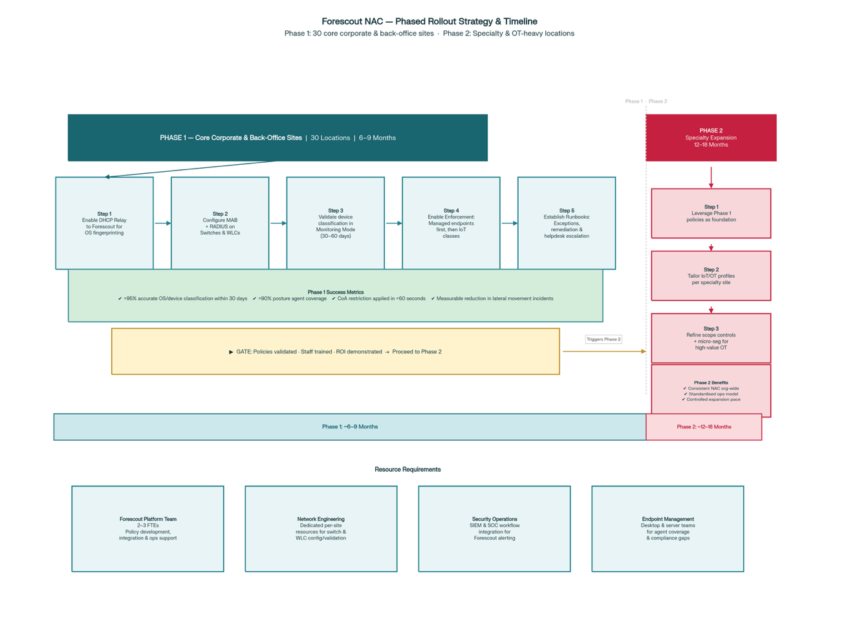
Phase 1: Core Corporate and Back-Office Sites (30 Locations)
The initial deployment targets 30 corporate headquarters, regional offices, and back-office retail/distribution centers where managed endpoint concentration is highest and operational risk is most manageable.
Implementation approach per site:
- Enable DHCP relay to Forescout appliances for OS fingerprinting and device classification
- Configure MAB and RADIUS integration on wired switches and wireless controllers
- Validate device classification accuracy and posture tier assignment in monitoring mode
- Progressively enable enforcement: first for managed Windows/macOS endpoints, then for IT IoT classes (printers, cameras) with established profiles
- Establish operational runbooks for posture exceptions, remediation workflows, and helpdesk escalation
Success metrics:
Greater than 90% accurate OS and device classification within 30 days
Greater than 75% posture coverage for managed endpoints (all agents reporting)
Proven CoA behavior with sub-60-second restriction application
Measured reduction in lateral movement attempts and incident impact duration
Timeline: 6-9 months for complete rollout across 30 core sites, including pilot validation, policy refinement, and staff training.
Phase 2: Specialty Locations Expansion
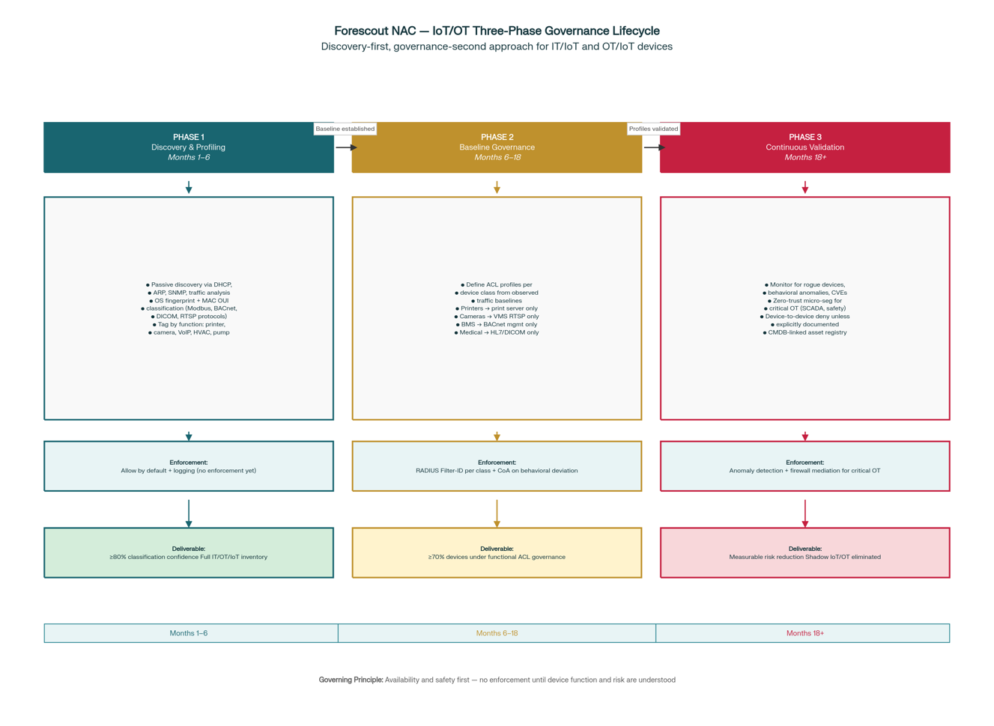
Once operational patterns, enforcement policies, and remediation workflows are validated at core sites, the architecture extends to specialty locations including high-value retail formats, specialized operations facilities, and OT-heavy environments.
Expansion approach:
Leverage proven policies and classification models from Phase 1 as foundation
Develop tailored IoT/OT governance profiles based on specialty location device populations and operational requirements
Implement refined discovery scope controls to manage Forescout licensing efficiently
Deploy tighter micro-segmentation for high-value systems while maintaining business uptime and safety requirements
Integrate specialty location asset inventory with enterprise CMDB for unified visibility
Strategic benefits:
Consistent NAC controls and security posture enforcement across all access layers organization-wide
Standardized operational model reduces complexity and training requirements
Controlled expansion pace aligned with business priorities and operational readiness
Incremental risk reduction with measurable ROI at each deployment milestone
Timeline: 12-18 months following Phase 1 completion, with deployment velocity adjusted based on specialty location complexity and resource availability.
Technical Foundation
Unified Wired and Wireless Enforcement
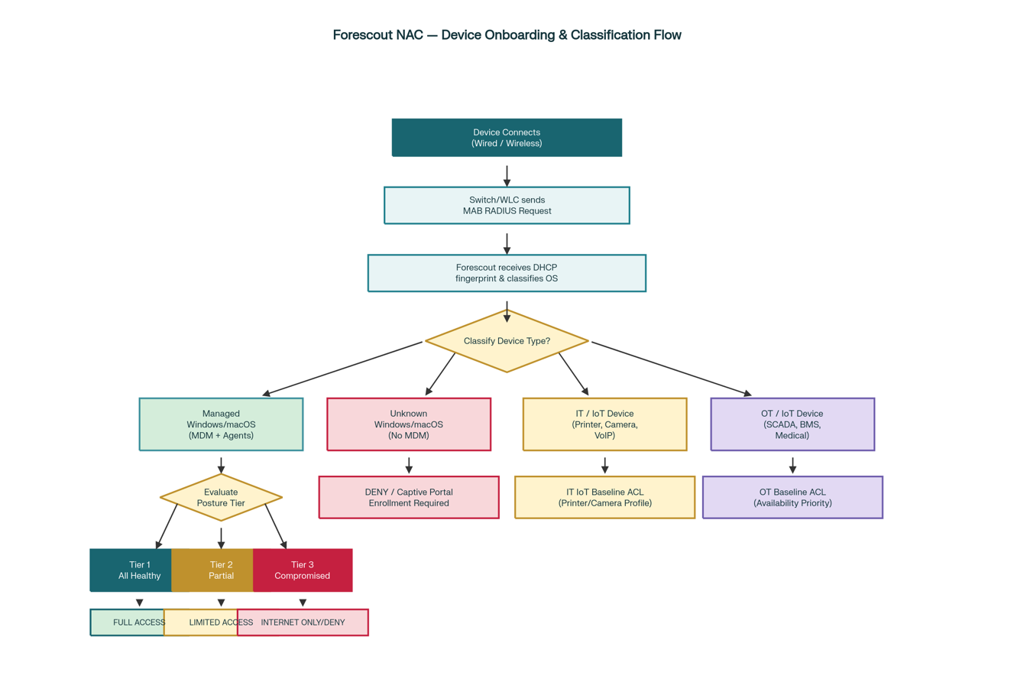
The architecture implements MAB-based RADIUS authorization uniformly across wired switch ports and wireless SSID connections, providing consistent posture enforcement without infrastructure changes.
For wired connections, access switches perform MAB authentication sending device MAC address to Forescout RADIUS; Forescout classifies the device, evaluates posture, and returns Access-Accept with Filter-ID selecting the appropriate ACL. Mid-session posture changes trigger RADIUS CoA from Forescout to the switch, applying updated ACLs without disconnection.
For wireless connections, WLAN controllers follow identical MAB flow with RADIUS-driven wireless roles/ACLs applied at the controller. Forescout supports both central switching architectures (enforcement at WLC or backhauled switch) using the same policy engine.
User experience: Employees connecting via Ethernet or Wi-Fi receive identical posture-based privileges. A compliant laptop receives full access regardless of connection method; if posture degrades, both wired and wireless access are restricted via CoA within seconds.
Integration Architecture
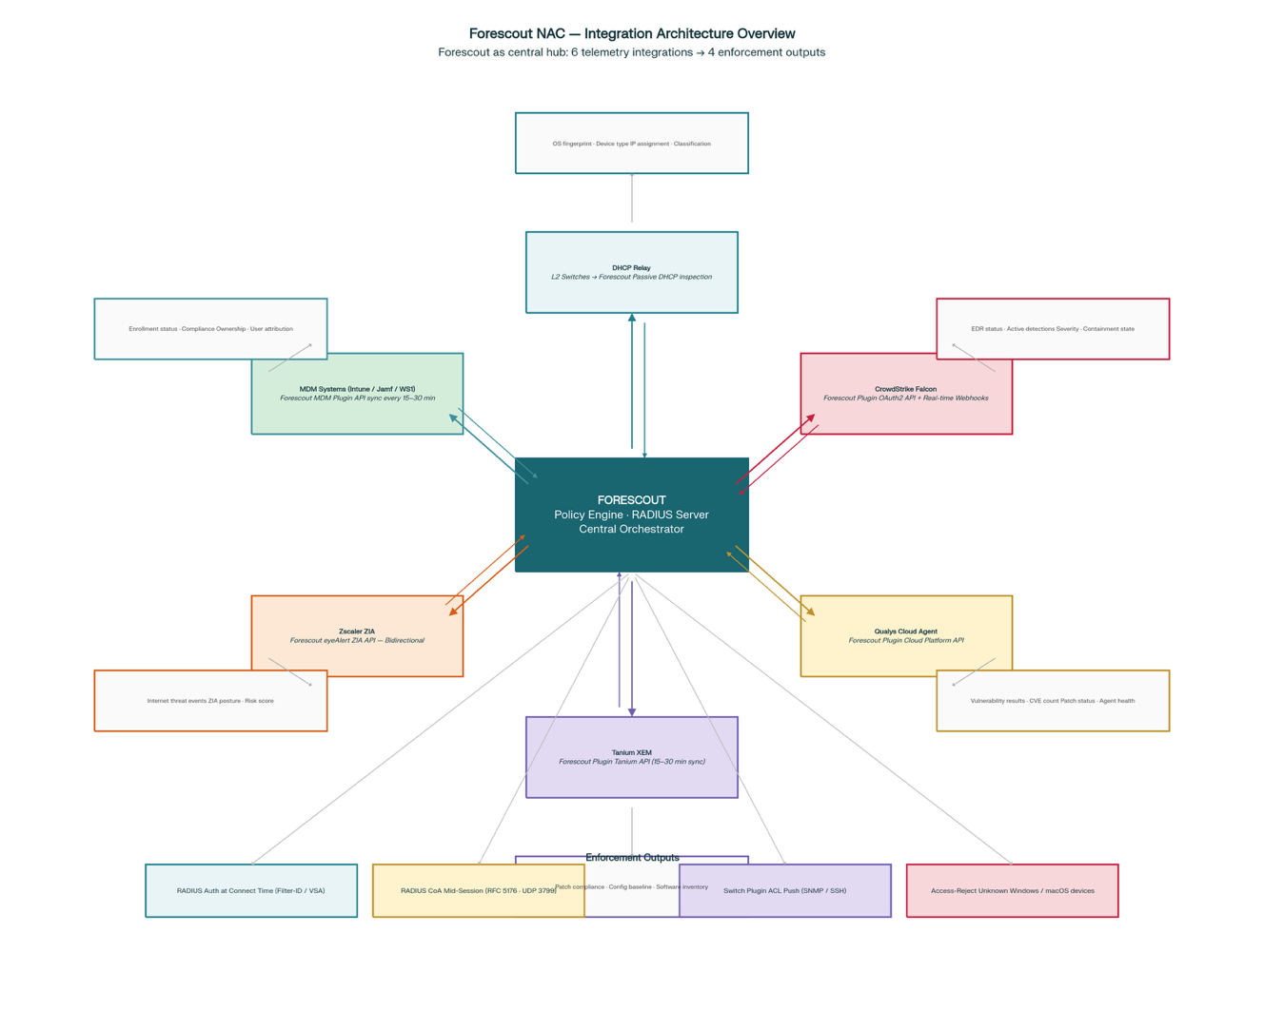
Forescout aggregates security telemetry from multiple enterprise platforms:
Integration | Data Provided | Integration Method
DHCP Relay | OS fingerprint, device type classification, IP assignment | L2 switches forward DHCP to Forescout for passive inspection
Forescout Agent | Agent health, detailed host attributes, software inventory | Agent reports to appliance via TCP 443
CrowdStrike Falcon | EDR sensor status, active detections and severity, threat indicators | Forescout plugin queries Falcon API; receives real-time webhooks
Qualys Cloud Agent | Vulnerability scan results and severity, patch assessment status | Forescout plugin queries Qualys Cloud Platform API
Tanium Client | Endpoint configuration compliance, patch deployment status | Forescout plugin queries Tanium platform via API
Zscaler ZIA | Internet security posture, cloud app usage, threat telemetry | Forescout plugin queries ZIA API for per-device posture
MDM Systems | Device enrollment status, compliance policies, management profiles | API integration or CMDB synchronization

Table 2: Security tool integrations providing posture telemetry
Scope Management and Licensing
Forescout licensing is device-based, requiring deliberate scope control to manage costs effectively. Discovery and enforcement are limited to explicitly defined network segments, VLANs, and device types based on risk priority.
In-scope priorities:
Managed Windows/macOS endpoints — highest lateral movement risk with full agent control capability
Unknown Windows/macOS — unauthorized endpoint risk requiring minimal licensing (deny at connect time)
High-risk IoT/OT — medical devices, industrial controllers in critical environments where inventory and anomaly detection justify investment
Low-value targets (public area devices, development systems) are excluded, directing licensing budget toward high-impact use cases. Scope is reviewed quarterly as security priorities evolve, acquisitions occur, or new high-risk populations are identified.
Organizational Readiness
Critical Success Factors
- Network Team Preparation — L2 switch and wireless controller configuration changes (DHCP relay, MAB, RADIUS) require coordinated planning and change control across 30+ sites
- Security Tool Health — Posture enforcement depends on agent coverage and telemetry quality from CrowdStrike, Qualys, Tanium, and Zscaler; gaps must be remediated before enforcement activation
- Helpdesk Training — Support staff require understanding of posture tiers, remediation workflows, and exception processes to handle user escalations effectively
- Executive Sponsorship — Enforcement activation will initially impact non-compliant devices; leadership support critical for managing change resistance and maintaining enforcement discipline
- Phased Enforcement Activation — Monitoring mode validation (30-60 days) before enforcement prevents unexpected business disruption and builds operational confidence
Resource Requirements
Forescout Platform Team — 2-3 FTEs for policy development, integration configuration, and operational support
Network Engineering — Resources as needed for per site for switch/wireless configuration support and validation
Security Operations — Integration of Forescout alerts into SIEM and SOC workflows for incident response
Endpoint Management — Coordination with desktop and server teams to resolve agent coverage gaps and compliance issues
Conclusion
The Forescout continuous monitoring NAC architecture delivers dynamic, posture-based access control that adapts to device security health in real time, preventing compromised or non-compliant systems from accessing sensitive resources. By implementing enforcement through RADIUS-driven ACLs within existing network infrastructure, the solution achieves measurable risk reduction without requiring topology redesign or operational disruption.
The phased rollout strategy—validating patterns and policies at 30 core corporate and back-office sites before expanding to specialty locations—ensures operational readiness, staff proficiency, and proven ROI at each milestone. The result is a scalable, sustainable NAC capability that reduces lateral movement risk, accelerates incident containment, and decreases operational overhead through automation, while maintaining the flexibility to adapt to evolving business requirements and security threats.

